**Lesson 2 Demo 1**

**Develop Hello World Sample Using Remix**

|  |
| --- |
| **Objective:** To connect to the online Remix IDE and explore its features  **Tools required:** Ubuntu, web browser, Remix IDE  **Prerequisites:** None |

**Step 1: Navigating to the Remix IDE web URL on the browser**

Open your web browser and navigate to <https://remix.ethereum.org/>

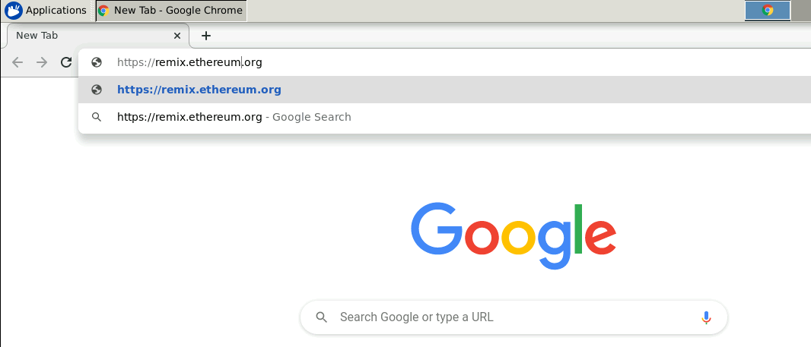

After the browser loads, it redirects to the Remix home page which consists of the file explorer, text editor, plugins, and the other tabs

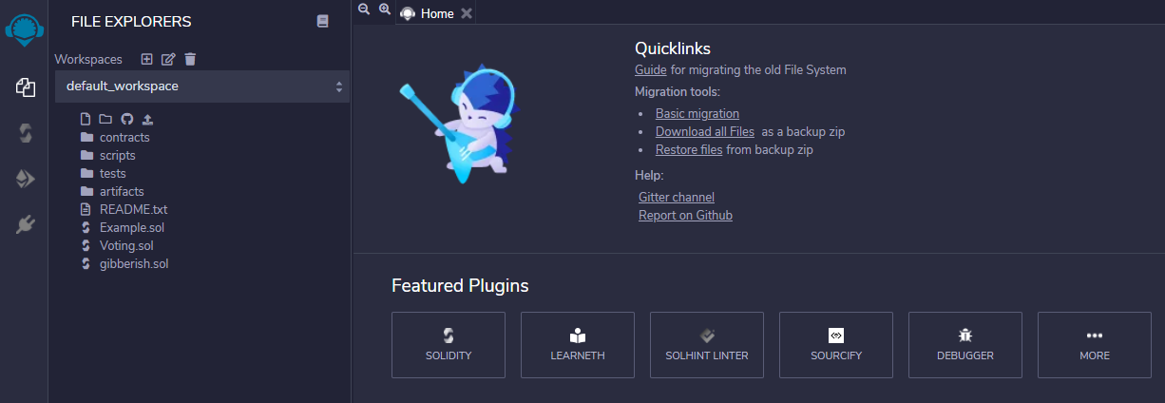

**Step 2: Create helloWorld Smart contract.**

The default tab when the IDE opens is the **File Explorer** and this tab displays the files and folders present

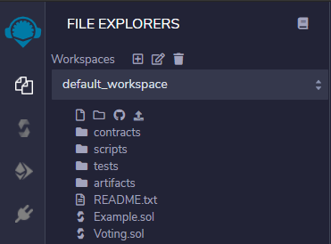

Go to contract folder and right click on that and create new file with the name helloWorld.sol.

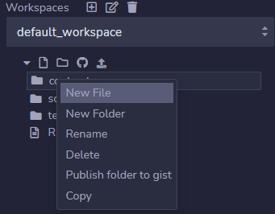

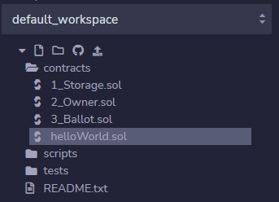

**Step 3: Add logic in helloWorld Smart contract.**

Take below content and past in helloWorld smart contract.

pragma solidity ^ 0.8.0;

contract helloWorld {

    function sayHello() public pure returns (string memory){

        return "Hello World";

    }

}

**Step 3: Compile helloWorld Smart contract.**

The **Solidity Compiler** lets you choose the language of development, the type of compiler, and the version of the compiler to be used.

Click on “Compile helloWorld.sol” to compile the smart contract.

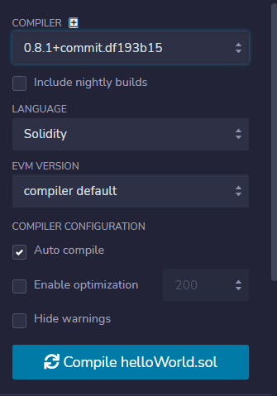

**Step 4: Deploy helloWorld Smart contract.**

The **Deploy & Run Transactions** section lets you configure the virtual environment to execute the smart contract, the **Account** from which we can transact Ethers, and the **Gas Limit** for your contract operations

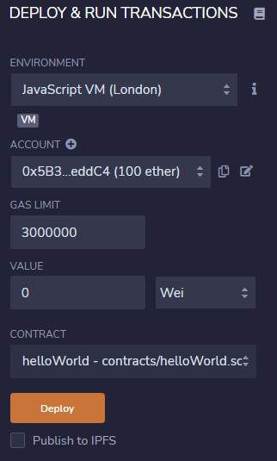

Choose “helloWorld” from the contract dropdown and click on deploy to deploy the smart contract to JavaScript VM (London).

**Step 5: Test helloWorld Smart contract.**

The **Deploy & Run Transactions** section also allows you to test the smart contract. To test the smart contract go to deployed contracts section and look for helloWorld smart contract.

You should notice sayHello function shown there.

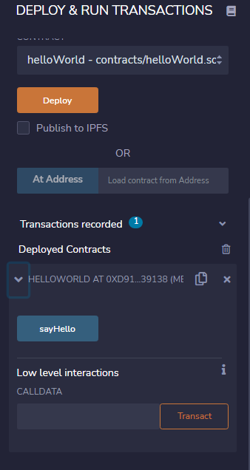

Click on that function and it should return you “Hello World”.

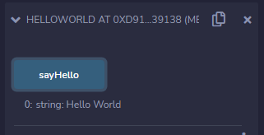

You can view the logs of that transaction in log section.

